Temsilcim Real Estate API – Assignment Document v1.0
- Project Overview
The Temsilcim Real Estate API is a RESTful API that allows users to register, log in, and manage real estate properties. It uses Node.js, Express, MongoDB, and JWT authentication.
Features:
- User registration and login with hashed passwords
- JWT-based authentication for protected routes
- CRUD operations for properties (create, read, update, delete)
- Relationships: each property is linked to a user

- Database Models
  - User Model
Collection: users
Fields:
Field | Type | Required | Notes
name | String | Yes | User's full name
email | String | Yes | Must be unique
password | String | Yes | Stored hashed (bcrypt)
createdAt | Date | Auto | Timestamp
updatedAt | Date | Auto | Timestamp
Behavior:
- Passwords are hashed before saving (bcrypt)
- JWT tokens are generated on login

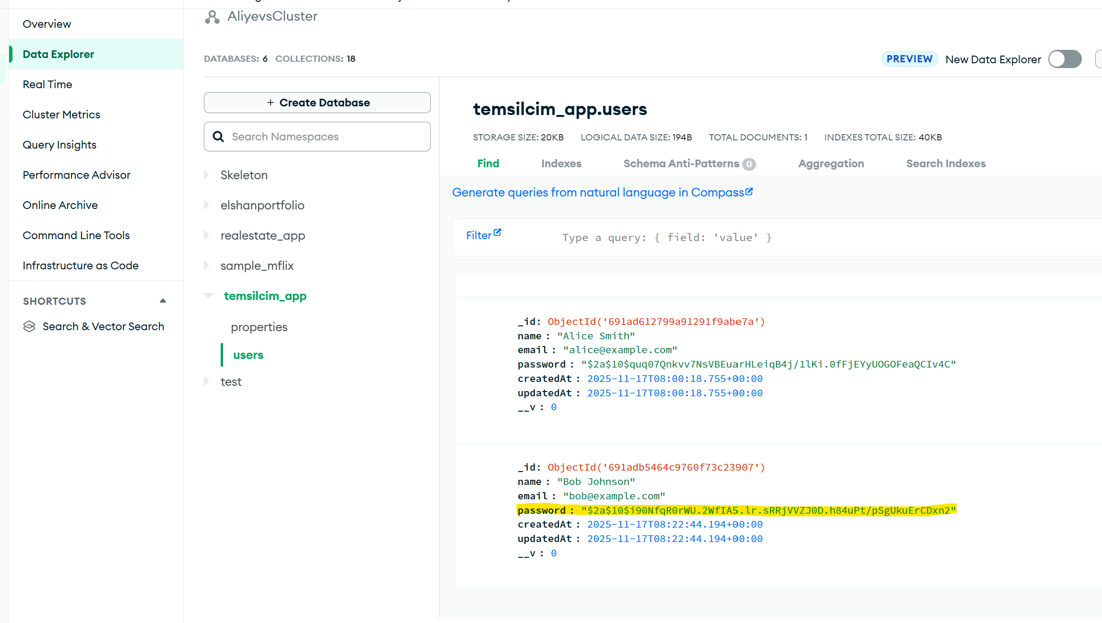

  - Property Model
Collection: properties
Fields:
Field | Type | Required | Notes
title | String | Yes | Property title
description | String | No | Optional description
type | String | Yes | Enum: ev, torpaq, obyekt, biznes
price | Number | Yes | Price of property
location | String | Yes | Address/location
ownerId | ObjectId | Yes | Reference to User
images | [String] | No | Array of image URLs
createdAt | Date | Auto | Timestamp
updatedAt | Date | Auto | Timestamp
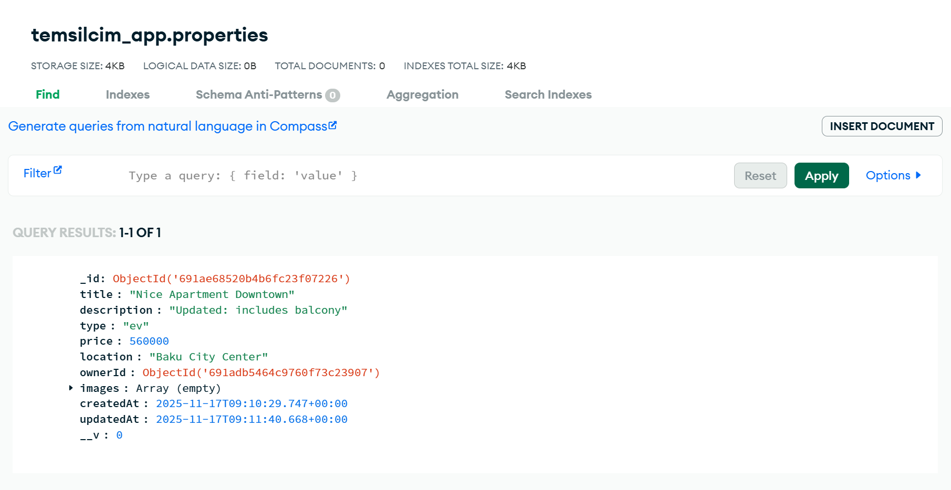

- API Endpoints
3.1 Authentication Routes
Base: /api/auth
POST /register
Description: Register a new user
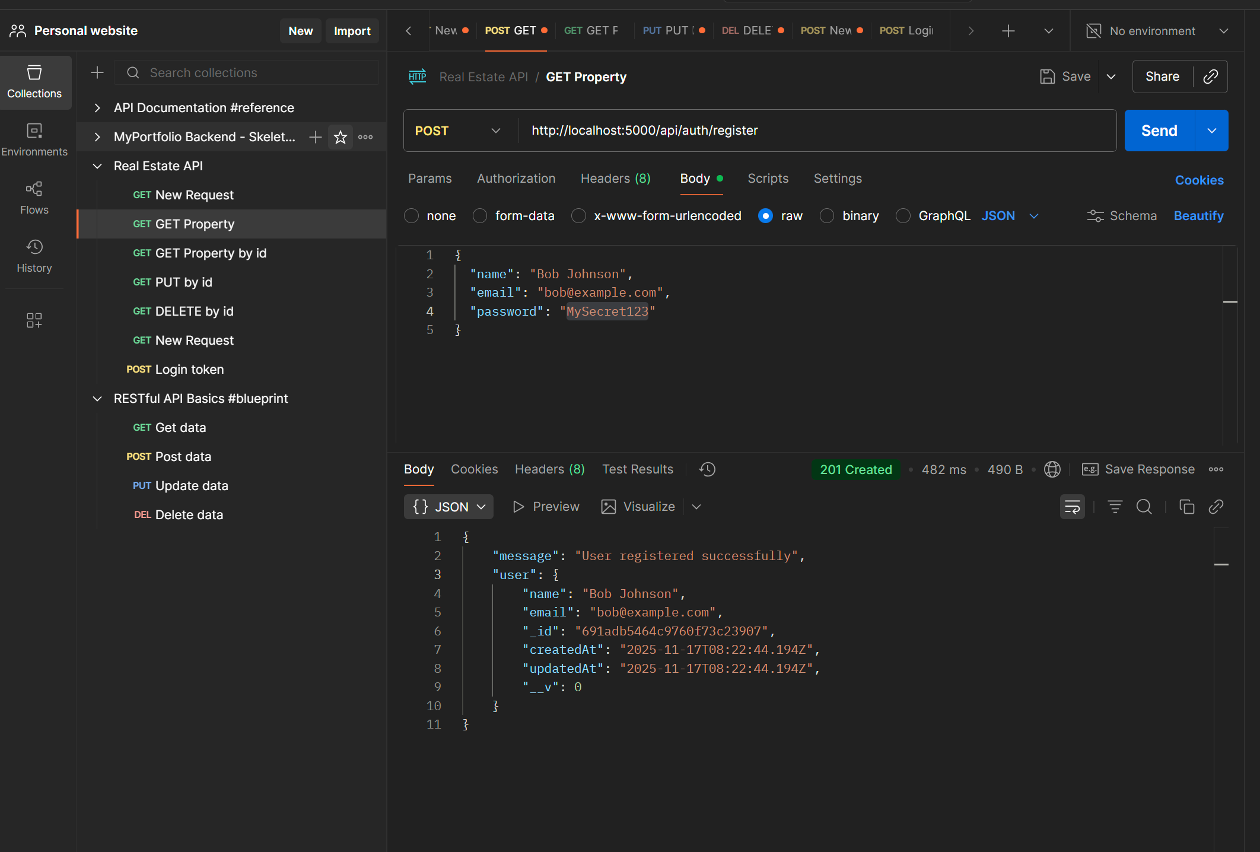

POST /login
Description: Log in user and get JWT token
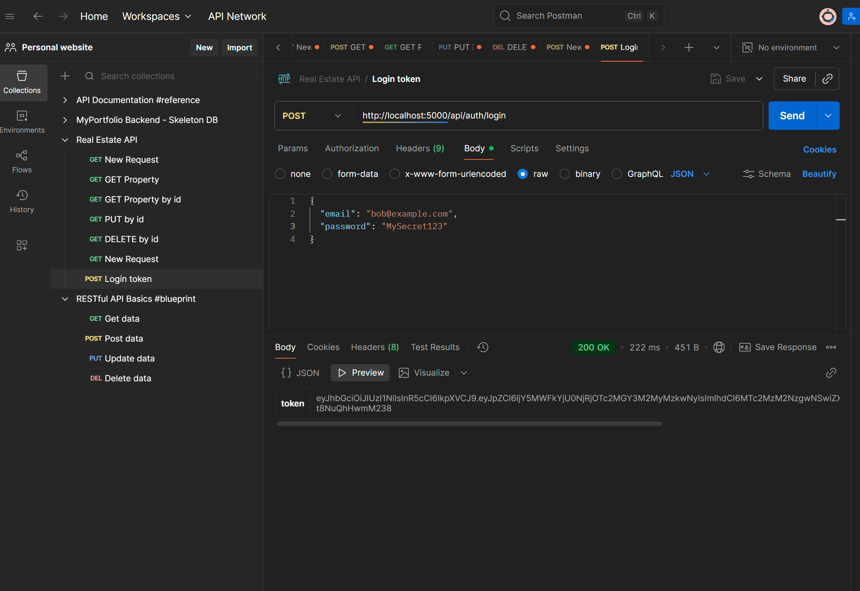

3.2 Property Routes
Base: /api/properties
Headers: Authorization: Bearer <JWT_TOKEN>
POST /
Description: Create a new property

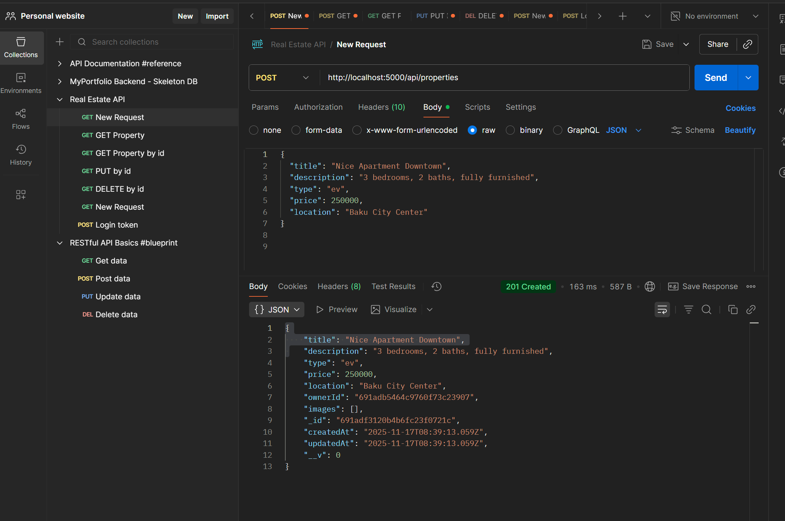

GET /
Description: Get all properties
Response: Array of properties with owner details
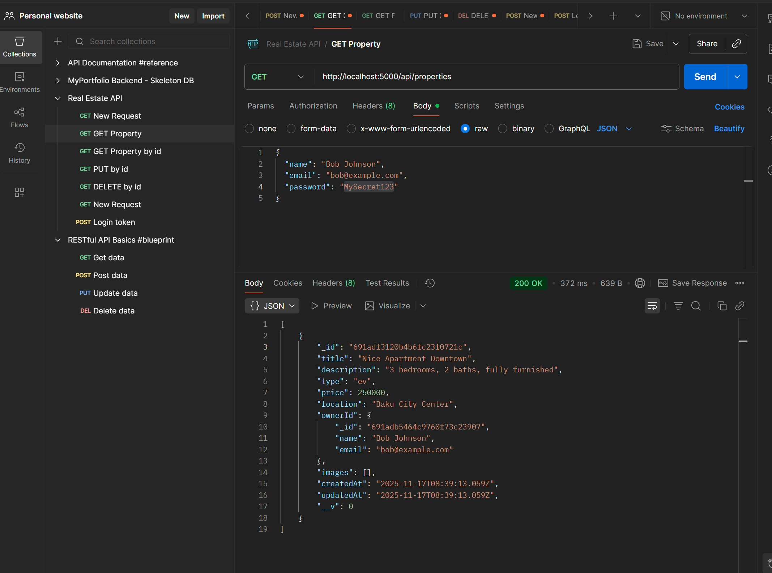

GET /:id
Description: Get single property by ID
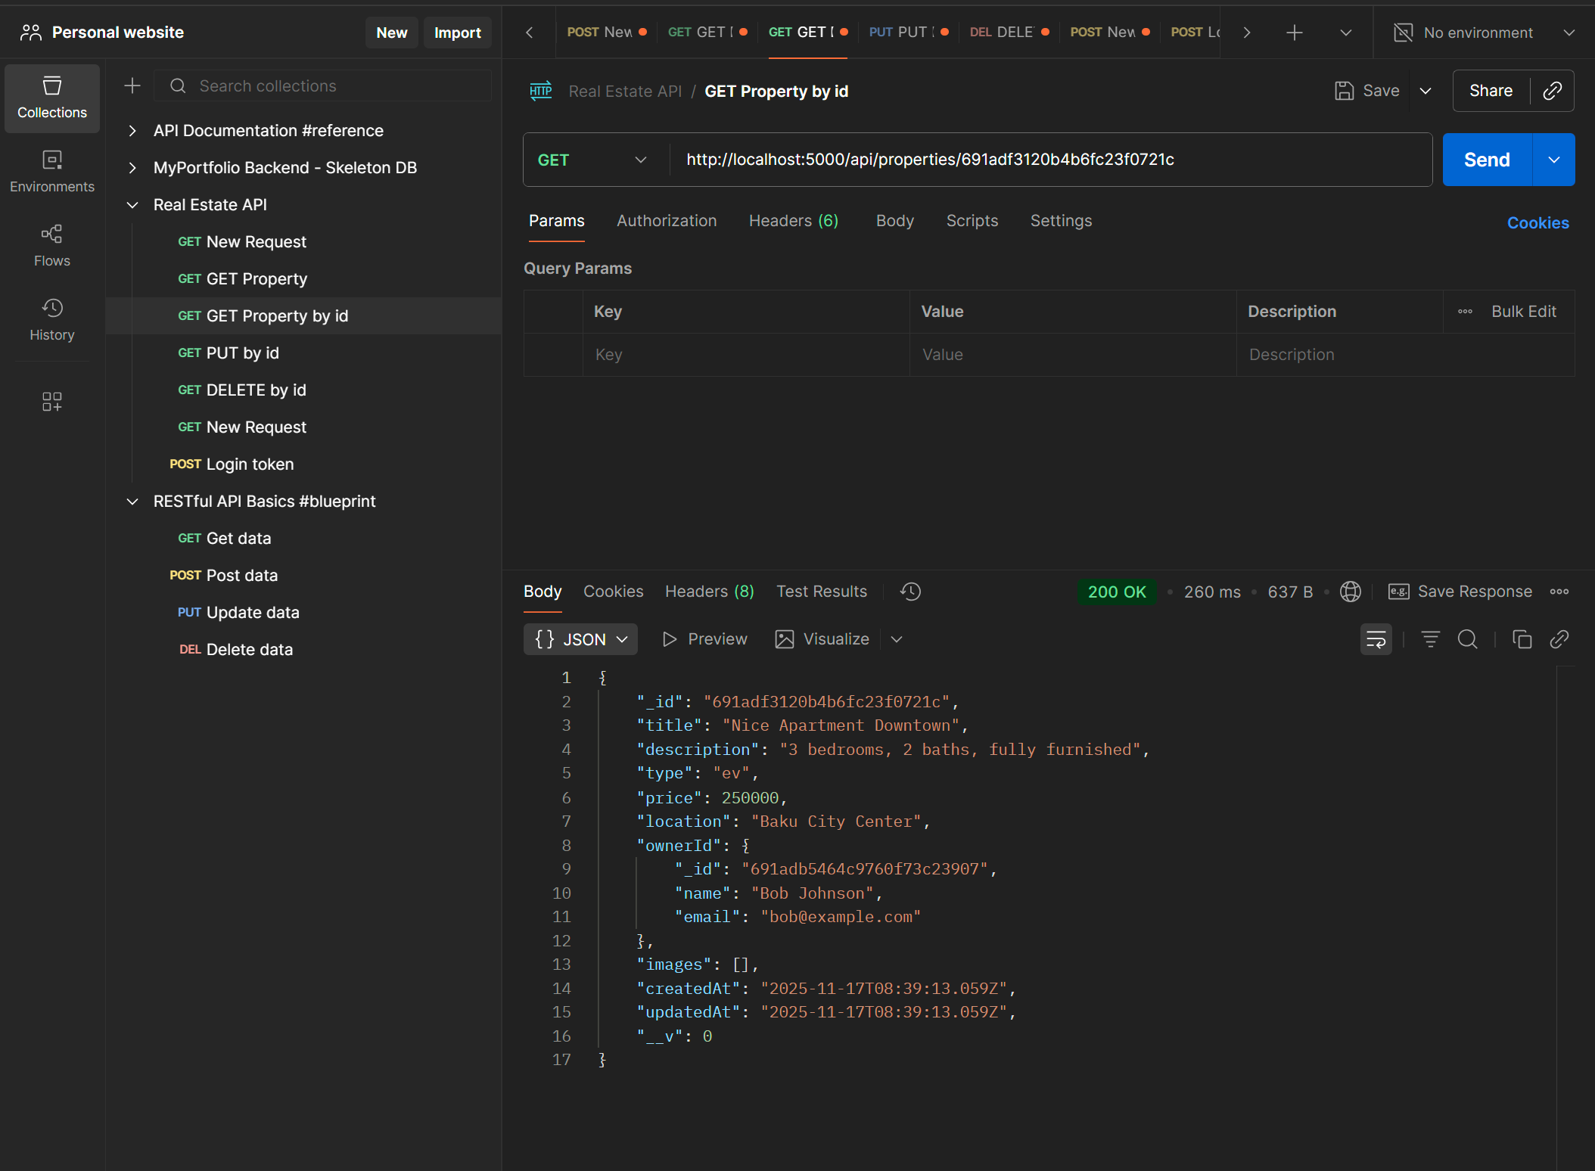

PUT /:id
Description: Update property by ID (only owner)

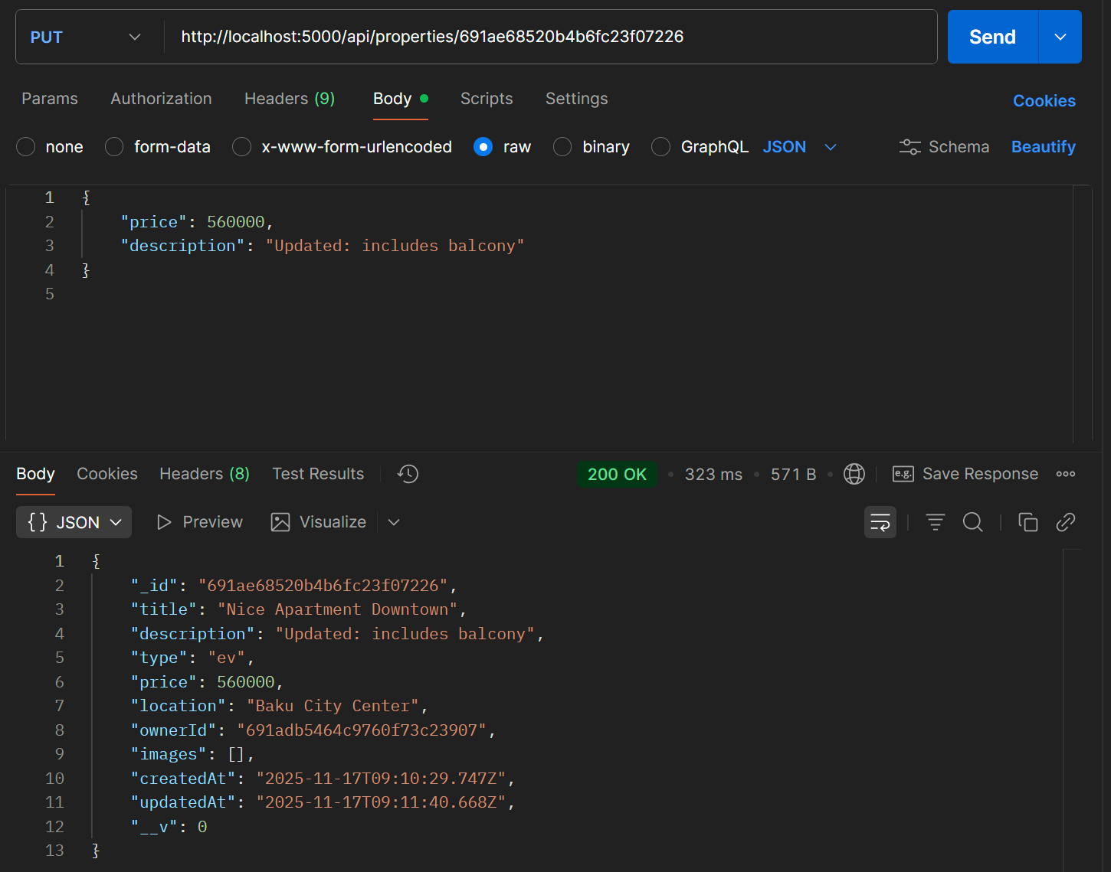

DELETE /:id
Description: Delete property by ID (only owner)
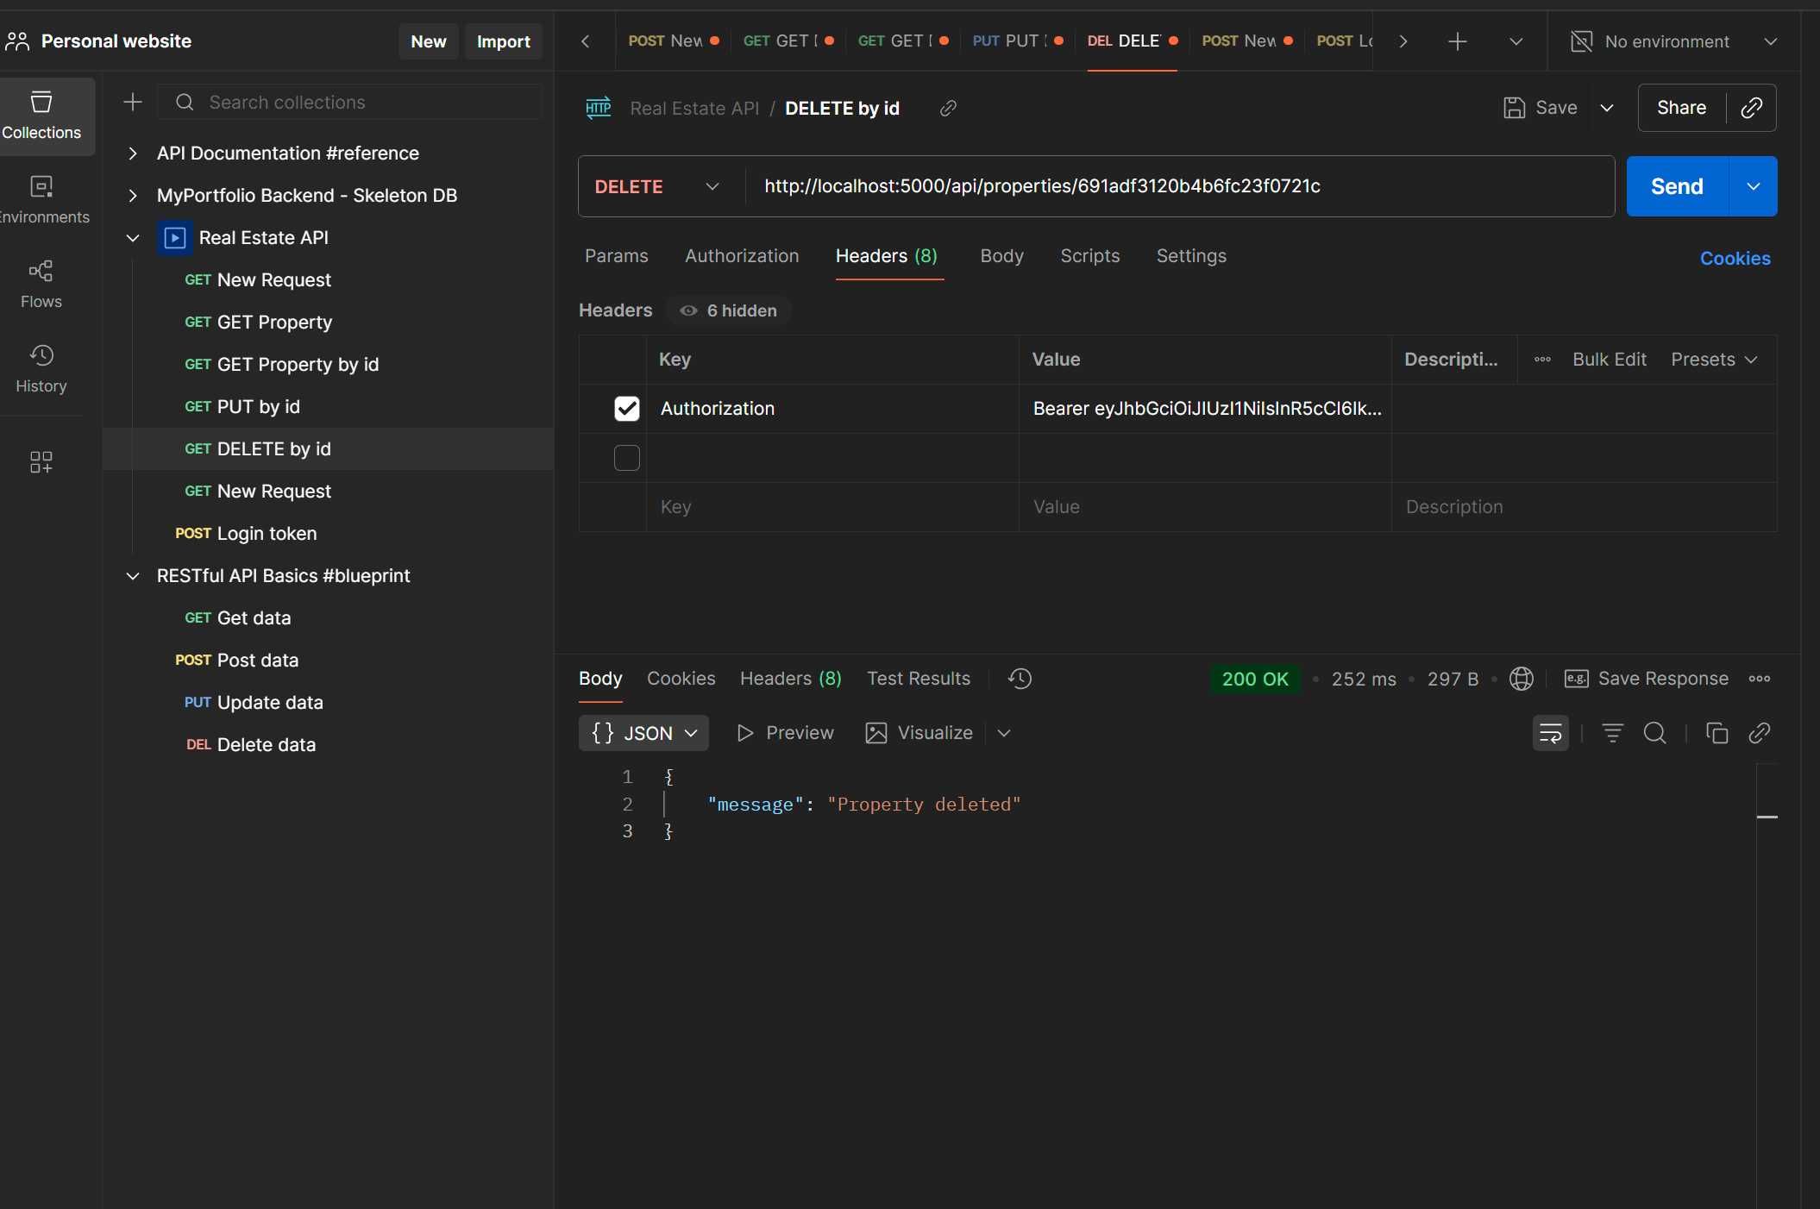

4. Authentication Flow
- Register → hashed password stored
- Login → verify password → JWT token returned
- Token sent in Authorization header → validated via middleware
- Only authenticated users can create/update/delete properties
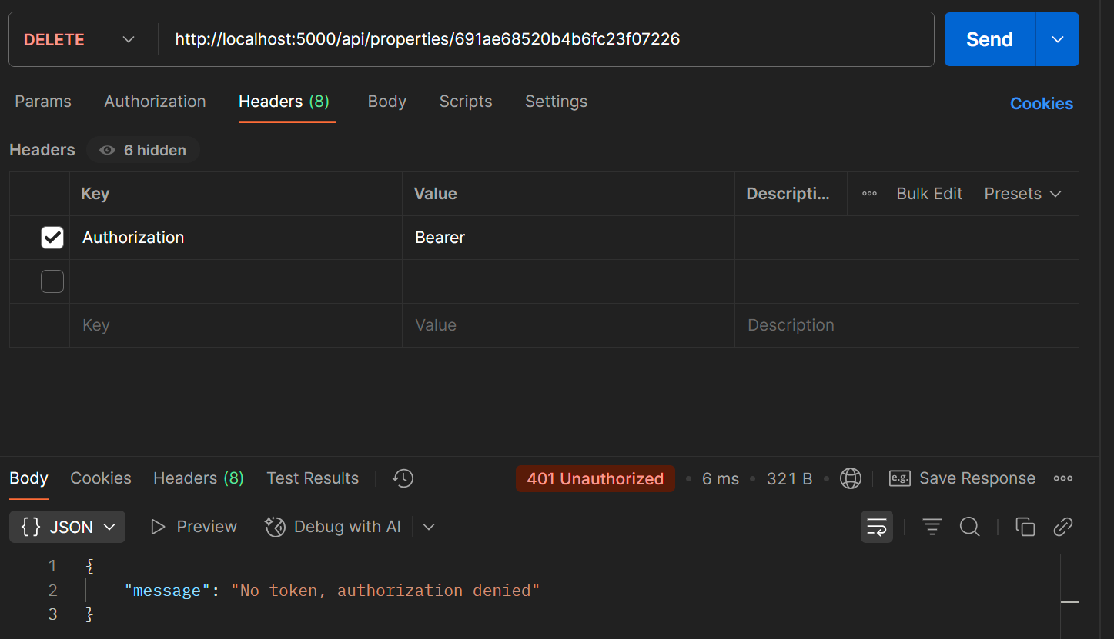

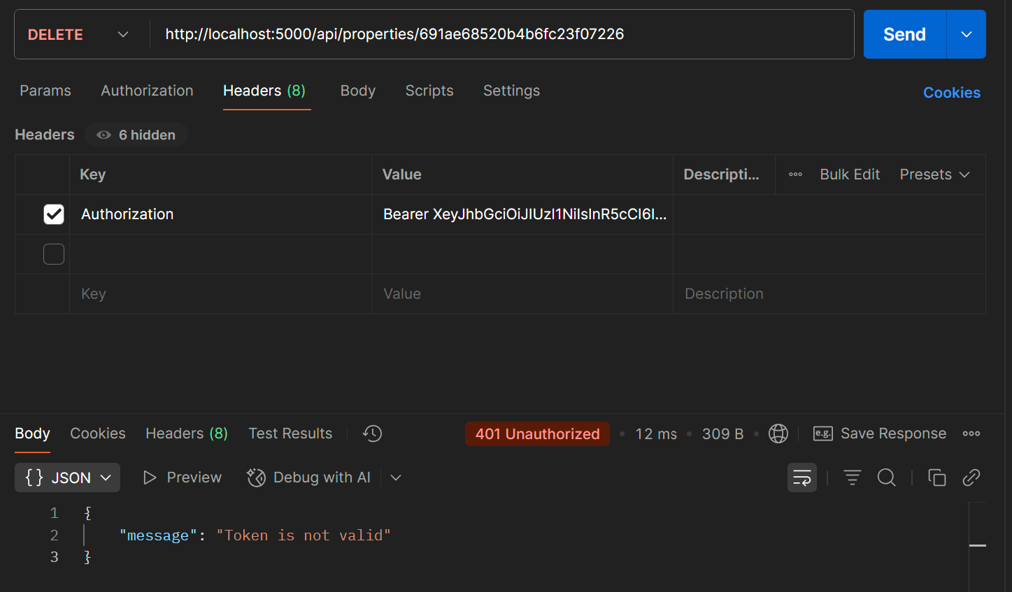
- Summary
The Temsilcim API provides a full stack for managing users and properties with authentication and CRUD operations. It demonstrates secure handling of user credentials, token-based authentication, and relational data management in MongoDB.

